
CONVERSATION-STATE BASED APPROACH
Assignment on

Assignment Report submitted in partial fulfilment of the requirements for the Course of

DSA0308 – Natural Language Processing
to the award of the degree of
BACHELOR OF Technology
IN
ARTIFICIAL INTELLIGENCE AND DATA SCIENCE
Submitted by
Malavathu Saiteja (192424034)
Under the Supervision of
Kumaragurubaran T

SIMATS ENGINEERING
Saveetha Institute of Medical and Technical Sciences
Chennai – 602105
SEPTEMBER 2026
Hybrid NLP and Machine Learning Model
1. Problem Statement and Problem Formulation
Problem Statement
An e-commerce chatbot must understand customer messages even when they contain morphological variations, different word combinations, negation, ambiguity and references to previous conversation turns. A system based only on rules may become difficult to maintain, while a machine-learning model alone may incorrectly classify context-sensitive statements.
For example, in:
“I don't want to cancel it. I just want to know when it will arrive.”
the word cancel may strongly indicate Order Cancellation, but the complete sentence actually expresses a rejection of cancellation and a request for delivery information.
Therefore, a hybrid system is proposed that combines linguistic NLP processing, machine learning classification and rule-based contextual correction.
Problem Formulation
Input: Multi-turn customer conversation.
Output:
- Extracted entities
- Linguistic features
- Initial ML intent
- Contextual corrections
- Final intent
- Retrieved information
- Generated response
- Tamil translation
The target intents include Order Tracking, Order Cancellation, Product Information, Return Request, Refund Request, Payment Problem, Delivery Information, Account Problem, Complaint and General Inquiry.

2. Objective and Expected Outcomes
Objectives
The objectives are to:
- Preprocess customer conversations.
- Extract morphological and syntactic features.
- Generate unigram, bigram and trigram features.
- perform POS tagging and CFG analysis.
- Detect negation.
- Extract semantic features.
- Resolve ambiguity and references.
- Use an ML classifier for initial intent prediction.
- Apply rule-based contextual correction.
- Retrieve relevant information and generate a suitable response.
- Translate the response into Tamil.
Expected Outcomes
The system should correctly identify the customer's requirement even when statistical and linguistic signals conflict.
For the given conversation, the expected final result is:
Final Intent: Order Tracking / Delivery Information

3. Requirements, Constraints and Assumptions
Requirements
The system should support:
- Text preprocessing
- Stemming
- N-gram generation
- POS tagging
- CFG parsing
- Negation detection
- Semantic feature extraction
- WSD
- Reference resolution
- ML-based classification
- Rule-based correction
- Information retrieval
- Response generation
- Tamil translation
These requirements correspond to the NLP pipeline and functional requirements defined in the assignment.
Constraints
- The solution must use multiple NLP concepts.
- Negated actions must not be treated as requested actions.
- Previous conversation context must be considered.
- Intermediate outputs should be available for validation.
- The system should not rely solely on keyword matching.
Assumptions
- A labelled e-commerce intent dataset is available.
- The chatbot processes conversations sequentially.
- A predefined intent set is used.
- A knowledge base is available for retrieval.
- Translation is performed after response generation.

4. Application of Relevant Course Knowledge / Concepts
Morphology
Stemming handles variations such as:
arrive → arriv
arrived → arriv
tracking → track
cancelled → cancel
N-Grams and POS
The system uses unigrams, bigrams and trigrams to capture word relationships.
For example:
track order
when arrive
cancel my order
POS tags help distinguish actions, objects and other grammatical components.
CFG and Negation
The sentence structure is analyzed using CFG rules, while negation identifies statements such as:
don't want to cancel
as a rejected action.
Semantics and WSD
Semantic features help associate expressions such as package, parcel and order with the appropriate e-commerce concepts.
Reference Resolution
Expressions such as “it”, “this order” and “that item” are resolved using previous conversational information.
These concepts are part of the five-unit NLP coverage required by the assignment.

5. Design / Proposed Solution / Methodology
The proposed architecture is:
Customer Conversation
↓
Regex
↓
Morphology
↓
N-grams + POS
↓
CFG + Negation
↓
Semantic Features
↓
WSD + Reference Resolution
↓
ML Classifier
↓
Rule-based Context Correction
↓
Final Intent
↓
Information Retrieval
↓
Response Generation
↓
Tamil Translation
The ML classifier provides the initial prediction, while the rule-based layer checks whether that prediction agrees with linguistic and conversational evidence.
For example:
ML Prediction
↓
Order Cancellation
↓
Negation detected
↓
Cancellation rejected
↓
Delivery request detected
↓
Final Intent = Order Tracking

6. Algorithm / Pseudocode / Flowchart
BEGIN
Load labelled dataset
Preprocess training data
Extract:
morphological features
n-grams
POS features
semantic features
Train ML intent classifier

FOR each conversation:

preprocess message

perform regex extraction

perform stemming

generate n-grams

perform POS tagging and CFG parsing

detect negation

extract semantic information

resolve ambiguous words

resolve references using conversation history

ML_intent ← classifier prediction

IF ML_intent is contradicted by negation:
modify intent score

IF contextual evidence supports another intent:
update intent score

final_intent ← highest corrected score

retrieve relevant information

generate response

translate response

END
The algorithm follows the assignment's requirement to combine linguistic processing, classification and contextual reasoning.

7. Implementation / Source Code and Environment / Tools Used
Component | Tool
Programming | Python
NLP | NLTK
Machine Learning | Scikit-learn
Regex | Python re
Vectorization | TF-IDF
Classifier | Logistic Regression / Linear SVM
POS | NLTK
CFG | NLTK
State/Rules | Python
Translation | Translation library/API

Main Modules
preprocess()
extract_regex_features()
stem_words()
generate_ngrams()
pos_analysis()
cfg_parse()
detect_negation()
semantic_analysis()
resolve_reference()
predict_intent()
apply_context_rules()
generate_response()
translate_response()
The implementation uses a modular structure so that the ML component and linguistic correction component can be evaluated separately.

8. Test Cases and Expected / Actual Results
Test Case | Input | Expected Intent
TC1 | “Where is my order?” | Order Tracking
TC2 | “Cancel my order.” | Order Cancellation
TC3 | “My package has not arrived.” | Order Tracking
TC4 | “I want to return this product.” | Return Request
TC5 | “My payment failed.” | Payment Problem
TC6 | “I don't want to cancel it. When will it arrive?” | Order Tracking
TC7 | “What features does this laptop have?” | Product Information

Critical Test
ML prediction:
Order Cancellation

Negation:
Detected

Context:
Customer rejects cancellation

Delivery request:
Detected

Final prediction:
Order Tracking
The actual confidence/probability values should be taken from the student's execution rather than inserted manually.

9. Execution Screenshots / Outputs
The implementation should capture screenshots showing:
Screenshot 1 — Preprocessing
Screenshot 2 — Linguistic Features
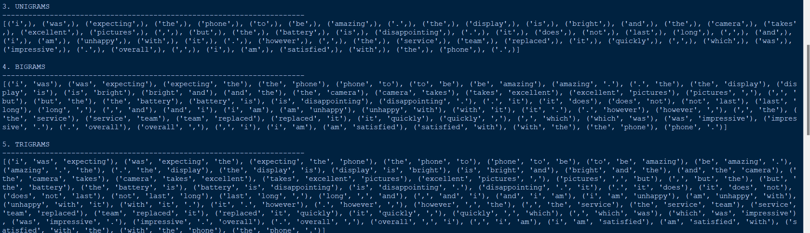
Screenshot 3 — ML Prediction
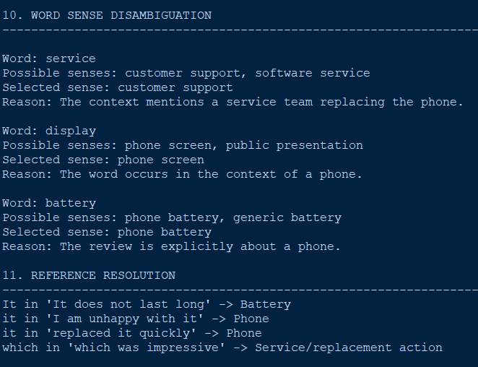
Screenshot 4 — Rule Correction
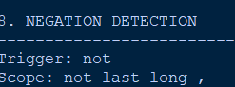
Screenshot 5 — Final Response

10. Results and Validation
Feature Validation
Component | Observation
Regex | Extracts structured information
Morphology | Reduces word-form variation
N-Grams | Captures local phrase patterns
POS | Adds grammatical information
CFG | Provides syntactic structure
Negation | Identifies rejected actions
WSD | Helps interpret ambiguous words
Reference Resolution | Connects expressions to previous entities
ML Classifier | Provides initial intent
Rule Correction | Resolves contextual conflicts

Main Conversation Result
Stage | Result
ML prediction | Cancellation-related
Negation analysis | Cancellation rejected
Semantic analysis | Delivery information requested
Reference resolution | “it” → order
Context correction | Changes prediction
Final intent | Order Tracking

For quantitative evaluation, the implementation should report actual accuracy, precision, recall, F1-score and confusion matrix obtained from the classifier. The assignment requires these forms of validation where applicable.

11. Analysis, Comparison, Trade-offs and Justification of the Final Solution
The major advantage of the hybrid approach is that it combines the strengths of two different methods.
Machine Learning
Advantages:
- Learns patterns from training data.
- Handles vocabulary variation.
- Reduces the need for manually writing every classification rule.
Disadvantages:
- May misinterpret negation.
- May depend strongly on training data.
- Can be difficult to explain for individual predictions.
Rule-Based Processing
Advantages:
- Easy to interpret.
- Useful for explicit linguistic conditions.
- Provides control over critical cases such as negation.
Disadvantages:
- Requires manual rule development.
- Large rule sets can become difficult to maintain.
- May not generalize well to unseen expressions.
Proposed Hybrid Model
Approach | Flexibility | Interpretability | Context Handling
Rule-based | Low | High | Moderate
ML | High | Moderate/Low | Limited
Hybrid | High | High | High

The hybrid solution is therefore justified because the ML model handles general language patterns while rules correct predictable contextual errors.

12. Broader Considerations / SDG Relevance
The chatbot relates to SDG 9 – Industry, Innovation and Infrastructure, as it applies NLP and machine learning to automated digital customer-service infrastructure.
Important considerations include:
- Privacy: Customer and order information should be protected.
- Bias: The classifier should be tested with varied language.
- Transparency: Rule-based corrections make important decisions easier to explain.
- Safety: Actions such as cancellation should require explicit confirmation.
- Accessibility: Tamil translation can improve regional-language accessibility.

13. Conclusion, Limitations and Possible Improvements
Conclusion
A hybrid NLP chatbot was proposed by combining linguistic processing, machine-learning classification and rule-based contextual correction.
The ML model provides a flexible initial intent prediction, while linguistic rules check negation, semantic evidence and conversational context. In the example conversation, the model may initially identify cancellation-related vocabulary, but the correction layer recognizes that cancellation is rejected and that the customer actually wants delivery information.
Therefore, the final intent is Order Tracking / Delivery Information.
Limitations
- Requires both training data and manually designed rules.
- Rules may need updating for new conversational patterns.
- ML accuracy depends on dataset quality.
- Complex references may still be difficult to resolve.
- Maintaining both components increases system complexity.
Possible Improvements
Future versions could use transformer-based classifiers, advanced coreference resolution, larger multilingual datasets and confidence-based human-agent escalation.

14. Individual Contribution of Group Members
The following should be modified according to the group's actual contributions.
Member | Contribution
R.Kalyan Kumar Reddy | Dataset preparation and preprocessing
M.Jagadeesh | Feature extraction and ML classifier
A Syed Thoufiq | CFG, negation and semantic processing
S Mohammed Abrar | WSD, reference resolution and contextual rules
V. Nagendra | Response generation, translation, testing and documentation
M. Saiteja | Testing and validation

15. References
References should include only the resources actually used, such as:
- NLP course textbook.
- NLTK documentation.
- Scikit-learn documentation.
- Python documentation.
- Research papers related to intent classification.
- Dataset source and documentation.
- Translation library/API documentation.
- Software and development tools used.
- AI-assisted tools, if used.
The assignment explicitly requires appropriate references for datasets, software/tools, research sources and AI-assisted tools where applicable.

16. One-Page Individual Reflection
Individual Reflection
This assignment helped me understand the importance of testing and validation in ensuring that a hybrid NLP and machine learning model performs reliably in real-world scenarios. My main focus was to evaluate how accurately the system interprets user inputs and produces appropriate responses.
The testing phase involved checking the model’s predictions against expected outputs. I used validation techniques such as train-test split and cross-validation to measure how well the model generalizes to new and unseen data. This process helped me identify whether the model was overfitting or underperforming.
One of the main challenges was handling ambiguous and complex sentences. For example, sentences with negation or multiple intents sometimes caused incorrect predictions. This showed me that testing is not just about accuracy, but also about understanding where and why the model fails. I used evaluation metrics like accuracy, precision, recall, and F1-score to analyze performance in detail.
I also tested how well the hybrid approach worked compared to using only machine learning. The rule-based components helped correct specific errors, especially in cases like negation and keyword conflicts. This demonstrated that combining validation with both statistical and rule-based checks leads to a more reliable system.
Another challenge was selecting appropriate evaluation criteria. I learned that relying only on accuracy can be misleading, and that other metrics provide better insight into model performance, especially for imbalanced data or critical tasks.
The project is connected to SDG 9 as it emphasizes building reliable and efficient AI systems for customer service applications. Proper testing ensures that such systems can be trusted in real-world deployment. Including Tamil language testing also highlights the importance of accessibility for diverse users.
If I continue improving this system, I would perform testing on larger datasets and use more advanced validation techniques. I would also include user-based testing to evaluate real interaction scenarios and improve overall system robustness.
Overall, this assignment strengthened my understanding of testing and validation in NLP systems. It showed me that careful evaluation is essential to build accurate, reliable, and user-friendly conversational models.

